# Lab 07

**Lab : 07**

**Name : MKSL Weerasiri**

**Registration Number : 220689N**

**Group No : 32**

# Introduction

## 1.1 Lab Task

In this lab, we are going to design and implement a 7–segment display. The 7 – Segment Display is a very basic display that has 7 segments to display a given value such as integers or some English letters. This lab is to connect it to our AU (Result of Lab 6) and display our AU results through it using a lookup table instead of using a logic function. Lookup table is a simple ROM, that is used to store and retrieve desired output without logic functions, just by looking at data in the memory.

## 1.2 Completed Table of Segments to Switch On

7 - Segment Display type in Basys3 board: common anode

|  |  |  |  |  |  |  |  |  |  |  |  |
| --- | --- | --- | --- | --- | --- | --- | --- | --- | --- | --- | --- |
| Output from RCA | | | | | Segments to Switch On | | | | | | |
| S3 | S2 | S1 | S0 | Hex. | A | B | C | D | E | F | G |
| 0 | 0 | 0 | 0 | 0 | 0 | 0 | 0 | 0 | 0 | 0 | 1 |
| 0 | 0 | 0 | 1 | 1 | 1 | 0 | 0 | 1 | 1 | 1 | 1 |
| 0 | 0 | 1 | 0 | 2 | 0 | 0 | 1 | 0 | 0 | 1 | 0 |
| 0 | 0 | 1 | 1 | 3 | 0 | 0 | 0 | 0 | 1 | 1 | 0 |
| 0 | 1 | 0 | 0 | 4 | 1 | 0 | 0 | 1 | 1 | 0 | 0 |
| 0 | 1 | 0 | 1 | 5 | 0 | 1 | 0 | 0 | 1 | 0 | 0 |
| 0 | 1 | 1 | 0 | 6 | 0 | 1 | 0 | 0 | 0 | 0 | 0 |
| 0 | 1 | 1 | 1 | 7 | 0 | 0 | 0 | 1 | 1 | 1 | 1 |
| 1 | 0 | 0 | 0 | 8 | 0 | 0 | 0 | 0 | 0 | 0 | 0 |
| 1 | 0 | 0 | 1 | 9 | 0 | 0 | 0 | 0 | 1 | 0 | 0 |
| 1 | 0 | 1 | 0 | A | 0 | 0 | 0 | 1 | 0 | 0 | 0 |
| 1 | 0 | 1 | 1 | B | 1 | 1 | 0 | 0 | 0 | 0 | 0 |
| 1 | 1 | 0 | 0 | C | 0 | 1 | 1 | 0 | 0 | 0 | 1 |
| 1 | 1 | 0 | 1 | D | 1 | 0 | 0 | 0 | 0 | 1 | 0 |
| 1 | 1 | 1 | 0 | E | 0 | 1 | 1 | 0 | 0 | 0 | 0 |
| 1 | 1 | 1 | 1 | F | 0 | 1 | 1 | 1 | 0 | 0 | 0 |

# Lookup Table

## 2.1 Design Source File

----------------------------------------------------------------------------------

-- Company:

-- Engineer:

--

-- Create Date: 03/19/2024 01:09:33 PM

-- Design Name:

-- Module Name: LUT_16_7 - Behavioral

-- Project Name:

-- Target Devices:

-- Tool Versions:

-- Description:

--

-- Dependencies:

--

-- Revision:

-- Revision 0.01 - File Created

-- Additional Comments:

--

----------------------------------------------------------------------------------

library IEEE;

use IEEE.STD_LOGIC_1164.ALL;

USE IEEE.NUMERIC_STD.ALL;

-- Uncomment the following library declaration if using

-- arithmetic functions with Signed or Unsigned values

--use IEEE.NUMERIC_STD.ALL;

-- Uncomment the following library declaration if instantiating

-- any Xilinx leaf cells in this code.

--library UNISIM;

--use UNISIM.VComponents.all;

entity LUT_16_7 is

    Port ( address : in STD_LOGIC_VECTOR (3 downto 0);

           data : out STD_LOGIC_VECTOR (6 downto 0));

end LUT_16_7;

architecture Behavioral of LUT_16_7 is

TYPE rom_type IS ARRAY (0 TO 15) OF STD_LOGIC_VECTOR (6 DOWNTO 0);

SIGNAL sevenSegment_ROM : rom_type := (

    "1000000",--0

    "1111001",--1

    "0100100",--2

    "0110000",--3

    "0011001",--4

    "0010010",--5

    "0000010",--6

    "1111000",--7

    "0000000",--8

    "0010000",--9

    "0001000",--A

    "0000011",--B

    "1000110",--C

    "0100001",--D

    "0000110",--E

    "0001110"--F

    );

begin

    data <= sevenSegment_ROM (TO_INTEGER(UNSIGNED(address)));

end Behavioral;

## 2.2 Elaborated Design Schematic

## 2.3 Simulation Source file

----------------------------------------------------------------------------------

-- Company:

-- Engineer:

--

-- Create Date: 03/19/2024 01:28:00 PM

-- Design Name:

-- Module Name: LUT_16_7_Sim - Behavioral

-- Project Name:

-- Target Devices:

-- Tool Versions:

-- Description:

--

-- Dependencies:

--

-- Revision:

-- Revision 0.01 - File Created

-- Additional Comments:

--

----------------------------------------------------------------------------------

library IEEE;

use IEEE.STD_LOGIC_1164.ALL;

-- Uncomment the following library declaration if using

-- arithmetic functions with Signed or Unsigned values

--use IEEE.NUMERIC_STD.ALL;

-- Uncomment the following library declaration if instantiating

-- any Xilinx leaf cells in this code.

--library UNISIM;

--use UNISIM.VComponents.all;

entity LUT_16_7_Sim is

--  Port ( );

end LUT_16_7_Sim;

architecture Behavioral of LUT_16_7_Sim is

COMPONENT LUT_16_7

    Port ( address : in STD_LOGIC_VECTOR (3 downto 0);

           data : out STD_LOGIC_VECTOR (6 downto 0));

END COMPONENT;

SIGNAL address : STD_LOGIC_VECTOR (3 DOWNTO 0);

SIGNAL data : STD_LOGIC_VECTOR (6 DOWNTO 0);

begin

    UUT : LUT_16_7

        PORT MAP(

            address => address,

            data => data

        );

    PROCESS

        BEGIN

            address <= "0000";WAIT FOR 100 NS;

            address <= "0110";WAIT FOR 100 NS;

            address <= "1010";WAIT FOR 100 NS;

            address <= "1111";WAIT FOR 100 NS;

    END PROCESS;

end Behavioral;

## 2.4 Timing Diagram

# 7 Segment Display

## 3.1 Design Source File

----------------------------------------------------------------------------------

-- Company:

-- Engineer:

--

-- Create Date: 03/19/2024 01:40:25 PM

-- Design Name:

-- Module Name: AU_7_Seg - Behavioral

-- Project Name:

-- Target Devices:

-- Tool Versions:

-- Description:

--

-- Dependencies:

--

-- Revision:

-- Revision 0.01 - File Created

-- Additional Comments:

--

----------------------------------------------------------------------------------

library IEEE;

use IEEE.STD_LOGIC_1164.ALL;

-- Uncomment the following library declaration if using

-- arithmetic functions with Signed or Unsigned values

--use IEEE.NUMERIC_STD.ALL;

-- Uncomment the following library declaration if instantiating

-- any Xilinx leaf cells in this code.

--library UNISIM;

--use UNISIM.VComponents.all;

entity AU_7_Seg is

    Port ( A : in STD_LOGIC_VECTOR (3 downto 0);

           Clk : in STD_LOGIC;

           RegSel : in STD_LOGIC;

           S_LED : out STD_LOGIC_VECTOR (3 downto 0);

           S_7Seg : out STD_LOGIC_VECTOR (6 downto 0);

           Carry : out STD_LOGIC;

           Zero : out STD_LOGIC);

end AU_7_Seg;

architecture Behavioral of AU_7_Seg is

COMPONENT AU

    Port ( A : in STD_LOGIC_VECTOR (3 downto 0);

           RegSel : in STD_LOGIC;

           Clk : in STD_LOGIC;

           S : out STD_LOGIC_VECTOR (3 downto 0);

           Zero : out STD_LOGIC;

           Carry : out STD_LOGIC);

END COMPONENT;

COMPONENT LUT_16_7

    Port ( address : in STD_LOGIC_VECTOR (3 downto 0);

           data : out STD_LOGIC_VECTOR (6 downto 0));

END COMPONENT;

SIGNAL S_adder : STD_LOGIC_VECTOR (3 DOWNTO 0);

begin

    AU_0 : AU

        PORT MAP(

            A => A,

            RegSel => RegSel,

            Clk => Clk,

            S => S_adder,

            Carry => Carry,

            Zero => Zero

        );

    LUT_16_7_0 : LUT_16_7

        PORT MAP(

            address => S_adder,

            data => S_7Seg

        );

    S_LED <= S_adder;

end Behavioral;

## 3.2 Elaborated Design Schematic

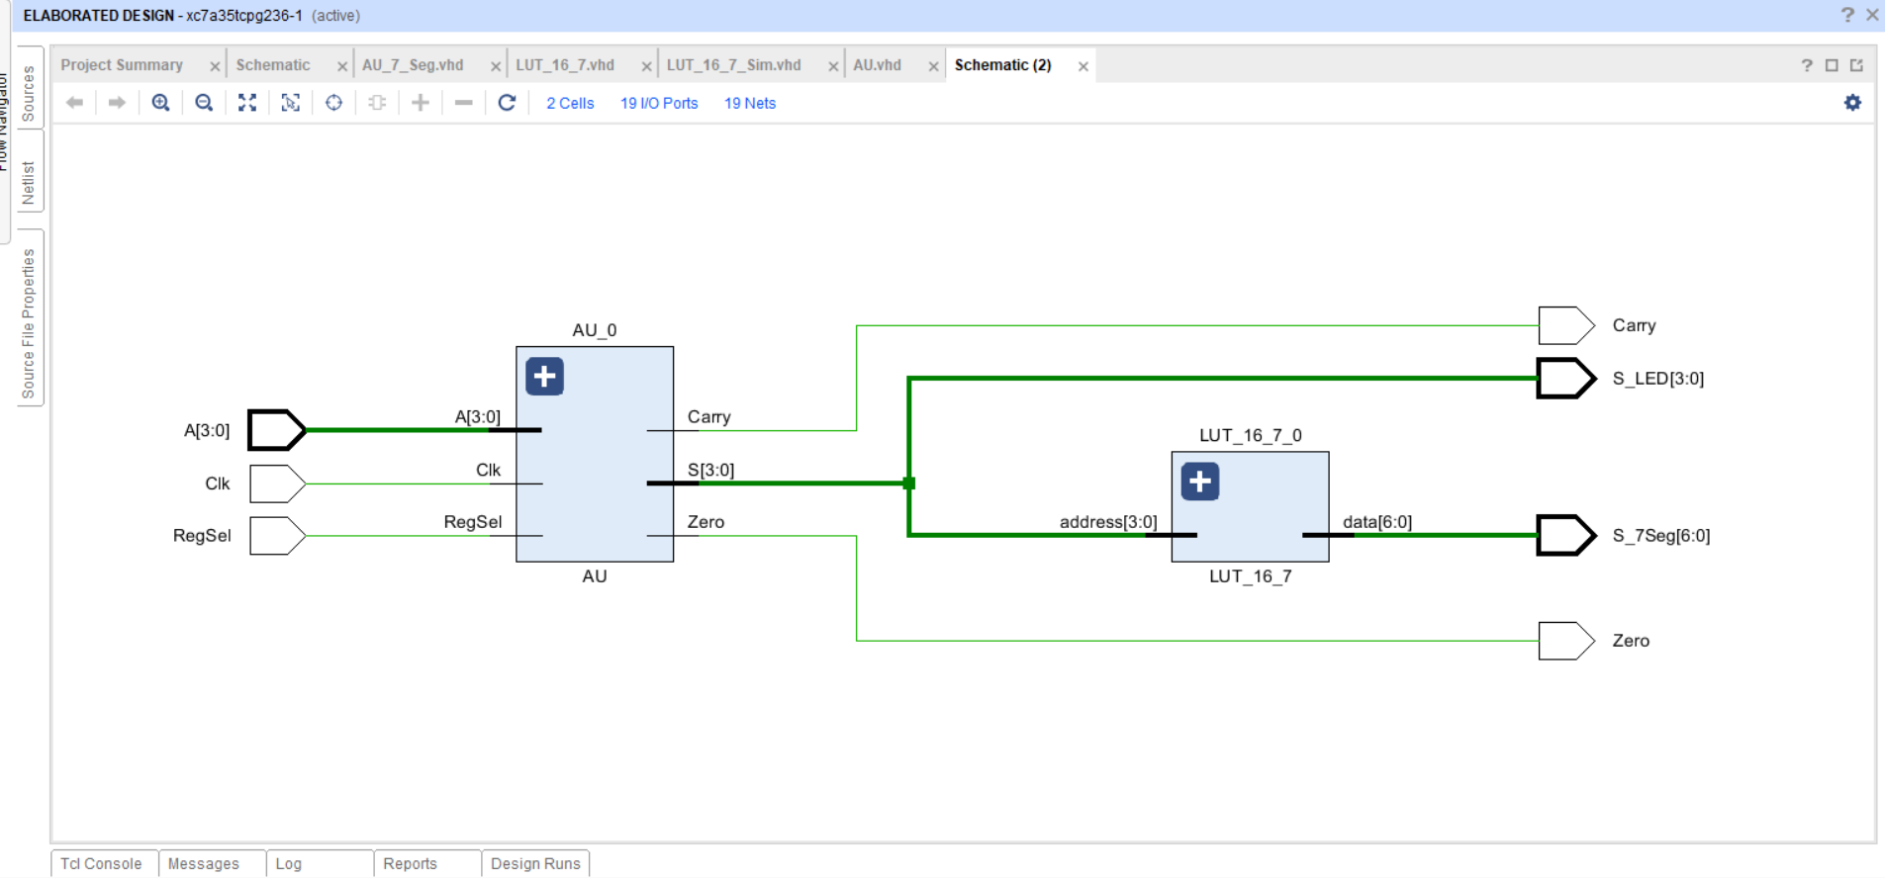

## 3.3 Implemented Design Schematic

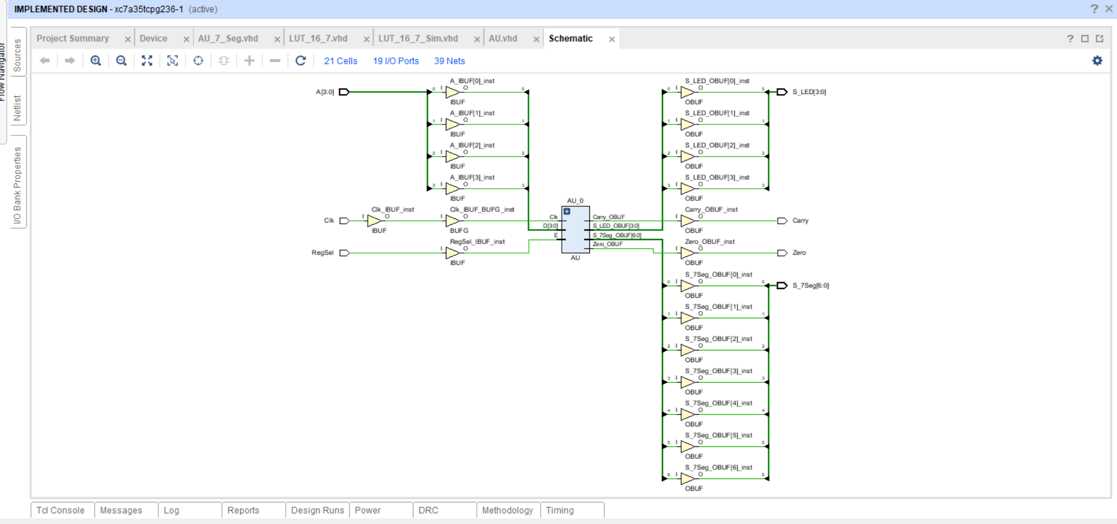

## 3.4 Constraints File

## Clock signal

set_property PACKAGE_PIN W5 [get_ports Clk]

    set_property IOSTANDARD LVCMOS33 [get_ports Clk]

    create_clock -add -name sys_clk_pin -period 10.00 -waveform {0 5} [get_ports Clk]

## Switches

set_property PACKAGE_PIN V17 [get_ports {A[0]}]

    set_property IOSTANDARD LVCMOS33 [get_ports {A[0]}]

set_property PACKAGE_PIN V16 [get_ports {A[1]}]

    set_property IOSTANDARD LVCMOS33 [get_ports {A[1]}]

set_property PACKAGE_PIN W16 [get_ports {A[2]}]

    set_property IOSTANDARD LVCMOS33 [get_ports {A[2]}]

set_property PACKAGE_PIN W17 [get_ports {A[3]}]

    set_property IOSTANDARD LVCMOS33 [get_ports {A[3]}]

set_property PACKAGE_PIN R2 [get_ports {RegSel}]

    set_property IOSTANDARD LVCMOS33 [get_ports {RegSel}]

## LEDs

set_property PACKAGE_PIN U16 [get_ports {S_LED[0]}]

    set_property IOSTANDARD LVCMOS33 [get_ports {S_LED[0]}]

set_property PACKAGE_PIN E19 [get_ports {S_LED[1]}]

    set_property IOSTANDARD LVCMOS33 [get_ports {S_LED[1]}]

set_property PACKAGE_PIN U19 [get_ports {S_LED[2]}]

    set_property IOSTANDARD LVCMOS33 [get_ports {S_LED[2]}]

set_property PACKAGE_PIN V19 [get_ports {S_LED[3]}]

    set_property IOSTANDARD LVCMOS33 [get_ports {S_LED[3]}]

set_property PACKAGE_PIN P1 [get_ports {Carry}]

    set_property IOSTANDARD LVCMOS33 [get_ports {Carry}]

set_property PACKAGE_PIN L1 [get_ports {Zero}]

    set_property IOSTANDARD LVCMOS33 [get_ports {Zero}]

##7 segment display

set_property PACKAGE_PIN W7 [get_ports {S_7Seg[0]}]

    set_property IOSTANDARD LVCMOS33 [get_ports {S_7Seg[0]}]

set_property PACKAGE_PIN W6 [get_ports {S_7Seg[1]}]

    set_property IOSTANDARD LVCMOS33 [get_ports {S_7Seg[1]}]

set_property PACKAGE_PIN U8 [get_ports {S_7Seg[2]}]

    set_property IOSTANDARD LVCMOS33 [get_ports {S_7Seg[2]}]

set_property PACKAGE_PIN V8 [get_ports {S_7Seg[3]}]

    set_property IOSTANDARD LVCMOS33 [get_ports {S_7Seg[3]}]

set_property PACKAGE_PIN U5 [get_ports {S_7Seg[4]}]

    set_property IOSTANDARD LVCMOS33 [get_ports {S_7Seg[4]}]

set_property PACKAGE_PIN V5 [get_ports {S_7Seg[5]}]

    set_property IOSTANDARD LVCMOS33 [get_ports {S_7Seg[5]}]

set_property PACKAGE_PIN U7 [get_ports {S_7Seg[6]}]

    set_property IOSTANDARD LVCMOS33 [get_ports {S_7Seg[6]}]

# Conclusion

In this lab, we have designed and implemented a simple display called a 7-segment display and checked it using our AU. And, to do that we have implemented a simple ROM to map our AU’s outputs to 7-segment display inputs.